Automatic Watering System

Team 206

NASA Gardeners

Olivia Pinkowski, Mannat Rana, Romney Kellogg, and Travis Casebolt

December 6th, 2019

Arizona State University - Polytechnic Campus

EGR 304 - Embedded Systems Design Project I

Dr. Shawn Jordan

Table of Contents

**Problem Definition:** **3**

Problem Statement: 3

Impact Statement: 3

Specifications: 4

Professor Defined: 4

Table 1: Professor and Class Defined Specifications 4

Team Defined: 6

Table 2: Specifications Defined by Team 206 6

**Team Member Accomplishments:** **8**

Travis Casebolt: 8

Romney Kellogg: 8

Olivia Pinkowski: 9

Mannat Rana: 9

**Hardware Design Narrative:** **11**

Electrical Block Diagram: 11

Figure 1: Final Block Diagram 11

Hardware Description: 11

Major Component Selection Rationale: 12

Table 3: Water Level Sensor 13

Table 4: Water Movement Solutions 14

Table 5: Power Supply 15

Table 6: Fuse Solutions 16

Table 7: 5V Regulator Solutions 17

Table 8: Moisture Sensor 18

Table 9: Potentiometer 19

Power Budget: 20

Table 9: Power Budget 20

Final Schematic: 22

**Software Design Narrative:** **23**

Software Design: 24

Figure 2: Software Diagram 24

Software Design Rationale: 24

**Mechanical Design Narrative:** **26**

Mechanical Design Rationale: 26

Project in Context: 28

Figure 3: Device in Use 28

Project Photos: 29

Figure 4: Assembled Planter Box Empty 29

Figure 5: Front View of Planter Box Empty 30

**Version 2.0+ and Lesson Learned** **31**

Hardware Design: 31

Software Design: 31

Mechanical Design: 32

Lessons Learned: 32

**Appendices:** **33**

Benchmarking: 33

Bill of Materials: 35

Printed Circuit Board Layout: 37

Figure 6: Final PCB Design from PCB Editor 37

Figure 7: PCB Editor PDF Print Out 38

Figure 8: Printed PCB 39

Figure 9: Soldered PCB 39

Code: 40

User Manual: 45

Figure 10: Image of the water tank filled to an appropriate level. 45

Figure 11: Image of the planter box filled with soil to an appropriate level. 46

Figure 12: An image of the moisture sensor placed correctly in the soil. 47

Figure 13: Power Supply 48

Figure 14: Image of the power switch while the device is on. 48

Figure 15: Screenshots of the Bluetooth screen. 49

Troubleshooting 49

CAD Model: 51

Figure 16: Empty Device 51

Figure 17: Device With Organic Material 51

References: 52

# Problem Definition:

## Problem Statement:

The purpose of our project is to create a system that efficiently and autonomously distributes water determined on the moisture level needs of plants for residents living in unideal growing areas, such as apartments in urban cities, while also reducing water waste for the end-user.

## Impact Statement:

Our device would reduce the effort required in maintaining a home garden. This garden will provide local and fresh produce to the user. It will reduce water usage and the costs associated with it. However, the user will have to sacrifice space within their home for the device and their electric bill will go up by powering the device.

## 

## 

## Specifications:

### Professor Defined:

#### Table 1: Professor and Class Defined Specifications

|  |  |  |  |  |  |  |  |  |
| --- | --- | --- | --- | --- | --- | --- | --- | --- |
| **#** | **Metrics** | **Units** | **Marginal Value** | **Ideal Value** | **Rationale** | **Electrical** | **Software** | **Mechanical** |
| 1 | Prototype budget  (Does not include development kits, components, or PCBs from PRLTA, components from outside of ASU, or free samples.) | $ | $40 / team member | < $40 / team member | The project must be affordable for the end-user. Therefore, the budget must be restricted as well. | - | - | All components and hardware bought from the team budget did not exceed 160$. |
| 2 | Power supply  (AC adapter, battery, or solar panel connected to a custom-designed voltage regulator circuit. No USB power packs.  This counts as a subsystem) | # | $≥1$ | # justified by design | The project’s design will require a valve, which requires a power source to operate. | A 12V Wall Plug functions as the team’s main power supply. | - | - |
| 3 | Cypress BLE Microcontroller  (Cypress Bluetooth Low Energy (BLE) Pioneer Kit (CY8CKIT-042-BLE-A), PSoC 4 Pioneer Kit (CY8CKIT-042) | # | $≥1$ | # justified by design | The project will send user notifications when the water level is low. | A PSoC 4 BLE is used as the microcontroller for the board. | The code has been written that utilizes the PSoC 4 BLE. | - |
| 4 | Sensor(s) read by a microcontroller  (Must have a custom-designed hardware signal conditioning circuit  These count as subsystems) | # | $≥1$ | # justified by design | A microcontroller is needed to read sensors so that the valve and Bluetooth work properly. | The board has one water level sensor and two moisture sensors. | The code is written to use and interpret the water level sensor and the two moisture sensors. | - |
| 5 | Actuator(s) controlled by a microcontroller  (These count as subsystems) | # | $≥1$ | # justified by design | The microcontroller needs to control the valve based on the sensor outputs. | The board has two water pumps wired through an L298 H-Bridge. | The code is written to turn on and off the water pumps as needed. | - |
| 6 | Bluetooth Low Energy (BLE) communications with a phone, computer, or other device using a Cypress BLE kit | # | $≥1$ | # justified by design | Bluetooth will be used to communicate with the user’s device. | The board includes a PSoC 4 BLE that is capable of using Bluetooth. | The code has been written to allow the user to read the output of the water level sensor from their phone. | - |
| 7 | Functioning custom printed circuit board  (Must be created in Cadence  No commercial boards (e.g., from Sparkfun)) | # | $≥1$ | # justified by design | The custom printed circuit board will connect all the major electrical components needed for proper functioning. | The team created the board with Cadence and manufactured it through the Peralta Lab. | - | - |
| 8 | Surface mount components  (Size 0805 or larger recommended) | # | $≥0$ | $≥1$ per team member | The boards will need a steady foundation as to make sure the electronics work reliably. | The team decided not to use surface mount components as we did not have the experience. | - | - |
| 9 | Programming language | programmed in C or C++ | | | C will be used to program and debug the project’s functioning. | - | The code written for this project is written all within PSoC creator which is C-based. | - |
| 10 | Electrical subsystem (#2, #4, or #5) designed and used in the final device | # | 1 by each team member | ∞ | All the subsystems must be connected and work together at the end of the project. | All four electrical subsystems are included and powered by the board. | The code has been written to use all four subsystems and make them interact with each other. | - |
| 11 | Functioning at Innovation Showcase | % | 50% functioning | 100% functioning | A functioning project is vital to attain future funding. | All four electrical subsystems are wired correctly and get power. | Code has been written so that all components interact with each other and that the PSoC has control. | The device has been constructed with durability and safety in mind. |

### 

### Team Defined:

#### Table 2: Specifications Defined by Team 206

|  |  |  |  |  |  |  |  |  |
| --- | --- | --- | --- | --- | --- | --- | --- | --- |
| **#** | **Metrics** | **Units** | **Marginal Value** | **Ideal Value** | **Rationale** | **Electrical** | **Software** | **Mechanical** |
| 1 | Watering Precision  (Dispense water in a controlled manner) | mL/s | $±25$ | $±3$ | Ensures the proper amount of water is given to the plants | Power will be sent directly to the water pumps and PSoC. | Will control how long the pumps can run before another check of the soil is initiated. | Capacitance sensor tells PSoC when water pumps should run or stop. |
| 2 | Record if Water Level is too low | % of Tank | 10 | 25 | The user will be informed about the amount of water in the tank. When the tank water level becomes lower than 25%, a notification will be sent and pumps will not run. | The regulator will send current through to the water level signal conditioning circuit. | When the connection is broken will send signal via Bluetooth to the user. | Wires will send current through to each side of the water level signal conditioning circuit and tell the PSoC if there is enough water in the tank. |
| 3 | Accurately measures the moisture in the soil | % of moisture | $±5$ | 15 | The device will rely on how much moisture is currently in the soil to know when to add more, the accuracy is crucial to the plant’s survival. Percentages based on soil moisture accuracy studies. | The regulator will power PSoC which will read the capacitance sensors. | PSoC will read the information being sent back from the capacitance sensors and determine if the soil needs water. | - |
| 4 | Square footage Occupied | $m^{2}$ | $±.25$ | 0.371612 | How much area the garden and water system will occupy. | - | - | Base rounded and cuts unnecessary space in the overall design to reduce size. |
| 5 | Voltage Required (AC) | V | <240 | <120 | Since this will be an indoor device it will need to be powered by a source that is available for a household. (USA Standard) | Will regulate power from a wall outlet to power the entire circuit board. | - | The switch will connect or disconnect power from the circuit. Only providing power when wanted. |
| 6 | Upper Noise Limit | dB | <90 | <40 | The device will be indoors and must not disturb the user’s everyday living. It must also not be loud enough to get a noise complaint from neighbors. | - | Only running loud components when needed to complete primary functions. | The only “noisy” component is the motors. It will only run when the soil needs water and overall not loud, to begin with. |
| 7 | Independence | # of interactions per week | 3 | 1 | How long the device can manage itself without human interaction. | The power supply comes from the wall outlet, so it will run until power is cut off. | The software does not get stuck, which allows it to run non-stop. | Water is the only limiting factor to how long the project can last on its own. This will depend on the plant being watered. |
| 8 | Total weight of System | kg | 35 | 25 | It allows for ease of movement and can be picked up by most people. | - | - | Unnecessary space cut out and reduction of parts leaves the project lightweight. |

# Team Member Accomplishments:

## Travis Casebolt:

I was tasked with figuring out how to measure how much water was in the water tank. I created the water level sensor signal conditioning circuit, which will allow us to be able to sense when the water tank reaches an unacceptable level of water. I also created both of the mechanical design prototypes based on the initial plan and feedback from TA’s during design review for our project. I helped with creating the final prototype base and gathering the materials that will be used for the final water tank/planters. I tried to make myself available as much as possible so that when someone needed help I could assist. I helped with all of the documentation throughout the semester and reworked some of the previous assignments in order to properly reflect feedback given by Dr. Jordan. I went to several TA’s office hours in order to help improve the efficiency of my circuit. The TA’s were also able to help me improve my soldering since my circuit ended up needing a lot of extra soldering to fix the errors that occurred during the creation of the PCB schematic in cadence. This helped me to be able to troubleshoot issues that were occurring when testing to see which systems were working on the PCB. Finally, I will be finishing up the final report and making sure that the final design of the project is fully functioning for Innovation Showcase.

## Romney Kellogg:

As a member of the team, I designed the capacitive moisture sensor subsystem. This subsystem measures the capacitance of the moisture in the soil by using an IC timer and a handmade capacitance sensor. I assisted with research on how to create a capacitive moisture sensor and assisted with creating the moisture sensor prototype. I also aided in finding suitable components needed for the subsystem such as the Ne555 timers and the potentiometers. I redesigned our Software Diagram after our team recognized several issues that came to our attention after the Design Review. Furthermore, my report writing skills were greatly utilized as I also edited the Problem Statement and various other team documents to ensure our team was communicating our ideas correctly and effectively. Outside of my subsystem, my main role was to assist and support our two team leads with the project. I did this by editing, updating and writing team documents, getting team documents reviewed by TAs, contributing ideas, and assisting with creating the sensor prototypes and the final prototype. Over the course of the semester, I went to many office hours of both the TAs and the instructor to receive advice, and help with my subsystem. Our team faced many challenges, both individually with our subsystems and with the group project. With the help of the TAs and the instructor I helped correct problems with my own subsystem and help solve challenges the team faced.

## Olivia Pinkowski:

As a member of the team, I spearheaded the pump driver circuit subsystem. I helped with the completion of the water level sensor and the moisture level sensor. I worked on testing the subsystems and integrating them to work together with Mannat. I soldered the final PCB and did most of the physical construction of the device. I worked through the debugging of the Peralta PCB with Mannat at many TA office hours and outside hours. I resolved many issues within the Peralta board with fly wires and in extreme cases hot glue. I modeled the final design within SolidWorks to visually represent the model and to acquire the files to manufacture the device in the Innovation Hub, utilizing the machinery available to us. I completed some research into the capacitive sensors and how to build them. I designed a model within SolidWorks to laser cut the sensor structure out of ⅛” acrylic. Then I used conductive tape to surface the acrylic and attached wire leads to connect it to the PCB. I then went through several iterations of water-sealing the structure. Dr. Jordan suggested using silicone instead of hot glue and Mykol suggested using a sleeve of heat shrink to seal the sides.

I helped Mannat with the debugging process of the code and establishing the logic behind the code. I helped test and implement the code and the subsystems. I went to many office hours and spoke with many TA’s while working through issues. I helped to rework the documentation to reflect feedback received throughout the semester including feedback from grades, Design Review, and office hours.

## Mannat Rana:

My main responsibility on the team was to create the power subsystem. The team required both a 12V power source as well as a 5V power source. I was able to accomplish these with a wall plug to generate the needed 12V and used a AP1086 5V regulator to create the 5V rail. After I had finished my subsystem, I also helped to get the Water Level Sensor and Moisture sensor working. For the moisture sensor, I had to go to office hours and find a design that would actually work.

I also had a heavy helping hand with creating all the hardware of the system. I had created the first draft of the team PCB, and also played a major role in finalizing the last design before we submitted it to printing, as I was responsible for adding the solder mask and rubout area for our board. I aided Olivia while she built the structure for our project, and I also helped debug many of the hardware issues that we encountered. I also made sure I worked on all team documentation in every assignment, as well as implementing the feedback received from the design review.

I was also in charge of coding the device. I designed and wrote the code for all of the subsystems, as well as Bluetooth. Getting a working code required major debugging on both the hardware and software side. I will also be helping heavily on the final assembly of the project and making sure that the project looks professional and is functional from both a hardware and software perspective.

# Hardware Design Narrative:

## Electrical Block Diagram:

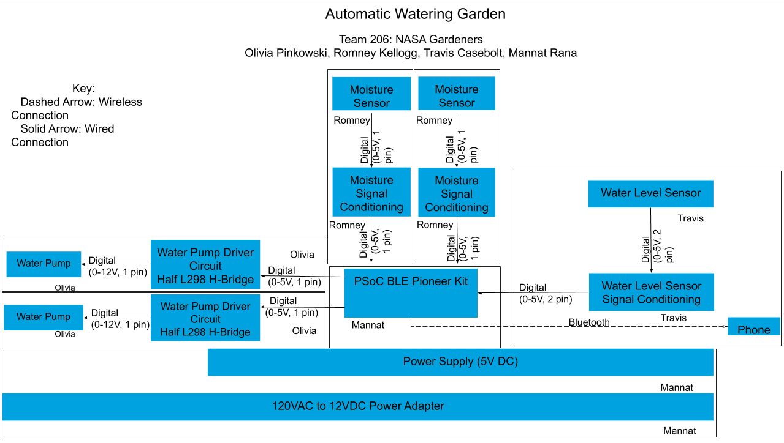

#### Figure 1: Final Block Diagram

## Hardware Description:

Each subsystem described in Figure 1, contributes to the functionality of the end product. The power system gives the system the power required to perform. Which is filtered before and after the voltage regulator via capacitors. This system gives the PSoC the power it requires to interpret the sensor that we built. The water pumps distribute the water from the water tank to the planter boxes. The water level sensor determines if there is enough water within the tank to distribute water to the planter boxes without breaking the pumps. The moisture sensors allow the product to determine the amount of water within the soil and determine if the planter boxes require more water.

For the water level sensor, we decided to condition the signal to be a digital high if there was water, allowing the circuit to be completed. If read as a digital low then there is no water bridging the two wires, thus making the circuit incomplete. This simplified the circuit and the code required to interpret it.

For the moisture level sensors, we decided to make the output from the PSoC digital high and the input back from the 555 Timer to also be interpreted as a digital high or low. Originally the idea was to have the output from the PSoC to be a digital high, causing the 555 to be triggered allowing the capacitor to be charged. The charge time would change based on the moisture level of the material above or around the sensor. That time would then be read by the analog ADC built within PSoC. This could not happen. The team discovered that the built-in timer was able to clock fast enough but the ADC was not able to read fast enough to match the clock and read the couple hundred nanoseconds that the charge time was outputting. This leads to the change to the hardware to condition the signal to be digital.

For the pump driving circuits and the pumps, we made the PSoC control the H-bridge with a digital high or low signal. This simplified the code and made the interface to the pumps simpler. With the pumps connected to the power rail and the H-Bridge acting as a switch to turn them on and off, the pumps each deliver water from the water tank to the individual plant boxes.

For the power system, we did not condition anything. This system was determined based on the other systems. It meets the current requirements and the voltage requirements set by the datasheets.

## Major Component Selection Rationale:

The Power System consists of a 120 Volt AC to 12 Volt DC wall adapter, a toggle switch, a 2A Fuse, and a 5V Regulator. The switch allows the device to be turned on/off and allows the team to power cycle the PSoC to help with debugging. It also allows the device to remain plugged in without continually sending power through the system. The fuse is there to self destruct when more than 2A drawn through it. This would help prevent the destruction of the rest of the circuit board.

#### 

#### Table 3: Water Level Sensor

|  |  |  |
| --- | --- | --- |
| Solutions | Pros | Cons |
| Option 1  311120001  $5.61  [Website/Datasheet Link](https://www.digikey.com/product-detail/en/seeed-technology-co-ltd/311120001/311120001-ND/5488120) | * Inexpensive * Easy circuit to build | * Have to buy 7 at a time * Not sure if it will function with PSoC * Will have to be connected to PCB and will be submerged in water |
| Option 2  2N3904FS-ND  $0.21  [Website/Datasheet Link](https://www.digikey.com/product-detail/en/on-semiconductor/2N3904BU/2N3904FS-ND/1413) | * Inexpensive * Simply Schematic * Works in a wide range of temperature | * Very small (easy to break) * Not waterproof |

**Rationale:** The team selected Option 2, the component with part number: 2N3904FS-ND.The Water Level Sensor circuit consists of 2N3904FS-ND (transistor) and a few wires. Compared to other choices such as the 311120001, both components were inexpensive but 311120001 was required to be bought in batches of 7. 2N3904FS-ND did not have this requirement and is mechanically easier to use for this circuit. With power running through the board it will only complete the circuit through the transistor when water is in between the two wires. This will allow the signal to go back into the PSoC, but when water no longer connects the circuit it will break the connection and send no signal to the PSoC.

#### Table 4: Water Movement Solutions

|  |  |  |
| --- | --- | --- |
| Solution | Pro | Con |
| Water Pump 1    $12.99  [Website/ Datasheet Website](https://www.digikey.com/product-detail/en/makeblock-co-ltd/50200/1890-1046-ND/7916864) | * Runs on 12V * Current with load <320mA * Flow 2Lpm * < 60dB | * 4 week lead time * Needs custom circuit to drive * Difficult to mount |
| Water Pump 2    $15.95  [Website/ Datasheet Website](https://www.digikey.com/product-detail/en/sparkfun-electronics/ROB-10398/1568-1344-ND/5684377) | * Runs 12V * 12 W * 12-15 Lpm * 0-32 PSI | * 2 week lead time * Needs custom circuit to drive * Made from plastic components, not durable in the long run |
| Submersible Water Pump    $9.48  [Website/Datasheet](https://www.digikey.com/product-detail/en/dfrobot/FIT0563/1738-1398-ND/8827828) | * Can be submerged * Runs on less power (6V-12V) * Would be hidden from view | * Only intended to operate under the water * Moves less water * Attaches to the surface with a suction cup |

**Rationale:** The team selected a water pump to help simplify the construction part of this project. Other system options involved more components and more expenses. A water pump comes pre-packaged to accomplish the task we are asking it to complete with the addition of the driving circuit. The team chose Water pump 3 because of its voltage range of operation, this pump worked well inside the 12V rail the team wanted to use while allowing for fluctuations. The price was similar enough to the other options that selecting option 3 made sense.

#### Table 5: Power Supply

|  |  |  |
| --- | --- | --- |
| Solution | Pro | Con |
| 12V, 24W Power Supply, 2A    $17.45  [Website/ Datasheet](https://www.digikey.com/product-detail/en/cui-inc/SWI24-12-N-P5/102-3623-ND/5415094) | * Small, Compact * Plenty of Power * Easy to use | * 12 week lead time * Unattractive * Wire is fragile |
| 12V, 12W Power Supply, 1A    $9.51  [Website/ Datasheet](https://www.digikey.com/product-detail/en/phihong-usa/PSAC12R-120/993-1359-ND/5418511) | * Easy to use * Can be easily hidden * Can be used in any standard American outlet | * More expensive * Less Power * Fragile Wire |

**Rationale**: The team has decided to go with the first wall plug. The reason for this decision is based on the amount of current one provides as opposed to the other. While the device can work on just 1A, have access to 2A allows the team to expand the project and make it much for flexible and reliable. Also, many user reports write that the first wall power supply is much more durable, and is rated very highly.

#### Table 6: Fuse Solutions

|  |  |  |
| --- | --- | --- |
| Solution | Pro | Con |
| FUSE CERAMIC 2A 500VAC 3AB 3AG  $4.87  [Website/ Datasheet](https://www.digikey.com/product-detail/en/littelfuse-inc/0514002.MXP/F10121-ND/7357005) | * Inexpensive * More versatile than glass * Faster than glass | * Delicate * Hard to inspect * Been used for less time than glass |
| Fuse Glass 3A 250VAC 5X20MM    $9.51  [Website/ Datasheet](https://www.digikey.com/catalog/en/partgroup/235-series/4415) | * Easy to attach * Small * Easier to inspect | * Lower Cold resistance * Cannot be used to replace a ceramic fuse * Lower breaking point |

**Rationale**: A fuse will be used in the project because it works as a fail-safe in the case that the circuit acts differently than expected. It will make sure that the rest of the hardware is unharmed in the event that something goes wrong. Also, they are easy to implement and replace in the case that they are broken. The ceramic fuse will be used in the design as it is safer and has a higher breaking point than the glass one.

#### 

#### Table 7: 5V Regulator Solutions

|  |  |  |
| --- | --- | --- |
| Solution | Pro | Con |
| Voltage Regulator - 5V  AP1086    $0.89  [Website/ Datasheet](https://www.digikey.com/product-detail/en/diodes-incorporated/AP1086T50L-U/AP1086T50L-UDI-ND/1301136) | * Inexpensive * Easy to install * Can handle large input voltage | * Only can provide 1.5A * May require a heatsink * Fragile |
| 5V 1.5A Linear Voltage Regulator - 7805 TO-220  <https://www.sparkfun.com/products/107>  $0.75  [Website/ Datasheet](https://www.adafruit.com/product/2164) | * Available video tutorials * Includes heat sink calculator * Easy to use | * Unclear Datasheet * Fragile |

**Rationale**: The team will be using the first 5V regulator due to the cleaner datasheet. Although it is slightly more expensive, the team felt that the more understood datasheet would be a worthwhile investment in the long run. There seems to be far more reliable reviews and guides for the first regulator as well.

#### 

#### Table 8: Moisture Sensor

|  |  |  |
| --- | --- | --- |
| Solution | Pro | Con |
| Option 1  Ne555l timer    $0.46  [Website/ Datasheet](http://www.ti.com/lit/ds/symlink/se555.pdf) | * No lead time * Uses capacitance * Draws a negligible amount of current * Sends time to measure capacitance * Cheaper * Highly rated | * Requires more labor time to put together * Capacitive sensors are harder to make and understand * Because we are making it ourselves there is more potential for human error |
| Option 2  MIC706PMY MicroChip    $0.87  [Website/ Datasheet](https://www.powell.com/item/Honeywell-Sensing-and-Control-700-102AAB-B00-GSorAZ/244573?gclid=CjwKCAjw5fzrBRASEiwAD2OSVwsBCQEQZHRZOdXbqZrqXNwnGp7Gbwtq5xVonJvzuDzGaqSXn6JjyxoCNeoQAvD_BwE) | * Highly rated * Can ship immediately * High operating temperature * High power dissipation | * Surface mount * More expensive |

**Rationale**: The team chose Option 1, the Ne555 timer because it will be used to help measure the capacitance of the moisture in the soil. This can be done in both components, but we opted for the first option because we were worried that we would damage the component while testing due to inexperience. The first option is cheaper which allows us to purchase more of them. They are also highly rated, very similar to the second option. We plan to use headers so we can easily change timers in case we damage them by accident.

#### 

#### Table 9: Potentiometer

|  |  |  |
| --- | --- | --- |
| Solution | Pro | Con |
| Option 1  202LF Potentiometer    $2.87  [Website/ Datasheet](https://www.instructables.com/id/Capacitive-Fluid-Level-Sensor/) | * Recommended by someone who has used one before * Has access to a classmate with experience using this * Gives 4-2k of resistance * Pins are inline | * More expensive |
| Option 2  104LF Potentiometer    $1.02  [Website/ Datasheet](https://www.powell.com/item/Honeywell-Sensing-and-Control-700-102AAB-B00-GSorAZ/244573?gclid=CjwKCAjw5fzrBRASEiwAD2OSVwsBCQEQZHRZOdXbqZrqXNwnGp7Gbwtq5xVonJvzuDzGaqSXn6JjyxoCNeoQAvD_BwE) | * Inexpensive * Up to 100kOhm | * Don’t have a friend who has used this one before * No experience using this one before * No one we can ask for help |

**Rationale**: The team chose Option 1, the 103LF potentiometer because while both seem viable options, and option 2 is cheaper, the team was recommended this potentiometer by another student that had experience using it. As a team, it is essential that the potentiometer works well or the user will not have accurate moisture readings for their plant. Because we want to make sure that we have a component we went with the recommendation rather than buying the cheaper one.

## 

## Power Budget:

The power supply has been designed in order to have a 12V and 5V rail while providing enough current for all subsystems. The 12V rail is present solely to power the two water pumps. The 12V wall power supply can provide up to 2A of current. Each pump requires 500mA. While we do have the current to power both the pumps, they will never be on at the same time. This is to ensure the electrical safety of the board. This gives us plenty of safety on the 12V rail. The 5V rail is present in order to power the PSoC and all of the sensors. While the regulator has a maximum output of 1.5A, the rail itself only requires around 300mA (200mA for the PSoC, and the other 100mA from the other sensors). This means that the 2A from the 12V Wall Supply is more than enough to power our whole device, including the safety margins.

#### Table 9: Power Budget

|  |  |  |  |  |  |  |  |
| --- | --- | --- | --- | --- | --- | --- | --- |
| **Team:** | 206 - Olivia Pinkowski, Romney Kellogg, Travis Casebolt, Mannat Rana |  |  |  |  |  |  |
| **Project Name:** | **Automatic Watering Garden** | | |  |  |  |  |
| ***All Major Components*** | | | | | |  |  |
| **All Components** | **Component Name** | **Part Number** | **Supply**  **Voltage**  **Range** | **#** | **Max Current (mA)** | **Total**  **Current**  **(mA)** |  |
|  | 12 V Power Supply | SWI24-12-N-P5 | 120V | 1 | 2000 | 2000 |  |
|  | VACUUM PUMP 12VDC 0-16" HG | FIT0563 | 6-12V | 2 | 500 | 1000 |  |
|  | 5V Regulator | AP1086 | 5 - 40V | 1 | 1500 | 1500 |  |
|  | PSoC™ 4 BLE Module | CY8C4247LQI-BL483 | 1.9 - 5V | 1 | 200 | 200 |  |
|  | Moisture Sensor Chip | NE555 | 5V | 2 | 3 | 6 |  |
|  | Water Level Sensor | DIY Water Level Sensor | .5 - 5V | 1 | 32 | 32 |  |
| ***Power Rails*** | | | | | |  |  |
| ***12V Power Rail*** | **Component Name** | **Part Number** | **Supply**  **Voltage**  **Range** | **#** | **Max Current (mA)** | **Total**  **Current**  **(mA)** |  |
|  | VACUUM PUMP 12VDC 0-16" HG | FIT0563 | 6-12V | 2 | 500 | 1000 |  |
|  | 5V Power Supply | AP1086 | 5V | 1 | 1500 | 305 |  |
|  | ***Subtotal*** | | | | | 1305 |  |
|  | ***Safety Margin*** | | | | | 25% |  |
|  | ***Total Current Required on 12V Rail*** | | | | | 1631.25 |  |
| ***5V Power Rail*** | **Component Name** | **Part Number** | **Supply**  **Voltage**  **Range** | **#** | **Max Current (mA)** | **Total**  **Current**  **(mA)** |  |
|  | PSoC™ 4 BLE Module | CY8C4247LQI-BL483 | 1.9 - 5V | 1 | 200 | 200 |  |
|  | Water Level Sensor | DIY Water Level Sensor | .5 - 5V | 1 | 32 | 32 |  |
|  | Moisture Sensor Chip | NE555 | 5-15V | 2 | 6 | 12 |  |
|  | ***Subtotal*** | | | | | 244 |  |
|  | ***Safety Margin*** | | | | | 25% |  |
|  | ***Total Current Required on 5V Rail*** | | | | | 305 |  |
| ***Voltage Supplies and Regulators*** | | | | | |  |  |
| **Supply** | **Regulator** | **Part Number** | **Input**  **Voltage**  **Range** |  | **Max Current (mA)** | **Required By**  **Rail(s) (mA)** | **Problem?** |
| Plug-in Wall Supply | 12V Regulator w/in Plug-in | SWI24-12-N-P5 | 90-264VAC |  | 2000 | 1631.25 | No |
|  | 5V Regulator | L7805 | 9-40V |  | 1500 | 305 | No |
|  | ***Subtotal*** | | | | | **1936.25** |  |
| ***Power Requirements*** | | | | | |  |  |
| **External**  **Supplies** | **Component Name** | **Part Number** | **Input**  **Voltage** | **Output**  **Voltage** | **Max Current (mA)** | **Required**  **By**  **Regulators** | **Problem?** |
|  | Plug-in Wall Supply | SWI24-12-N-P5 | 120VAC | 12VDC | 2000 | 1936.25 | No |

## 

## Final Schematic:

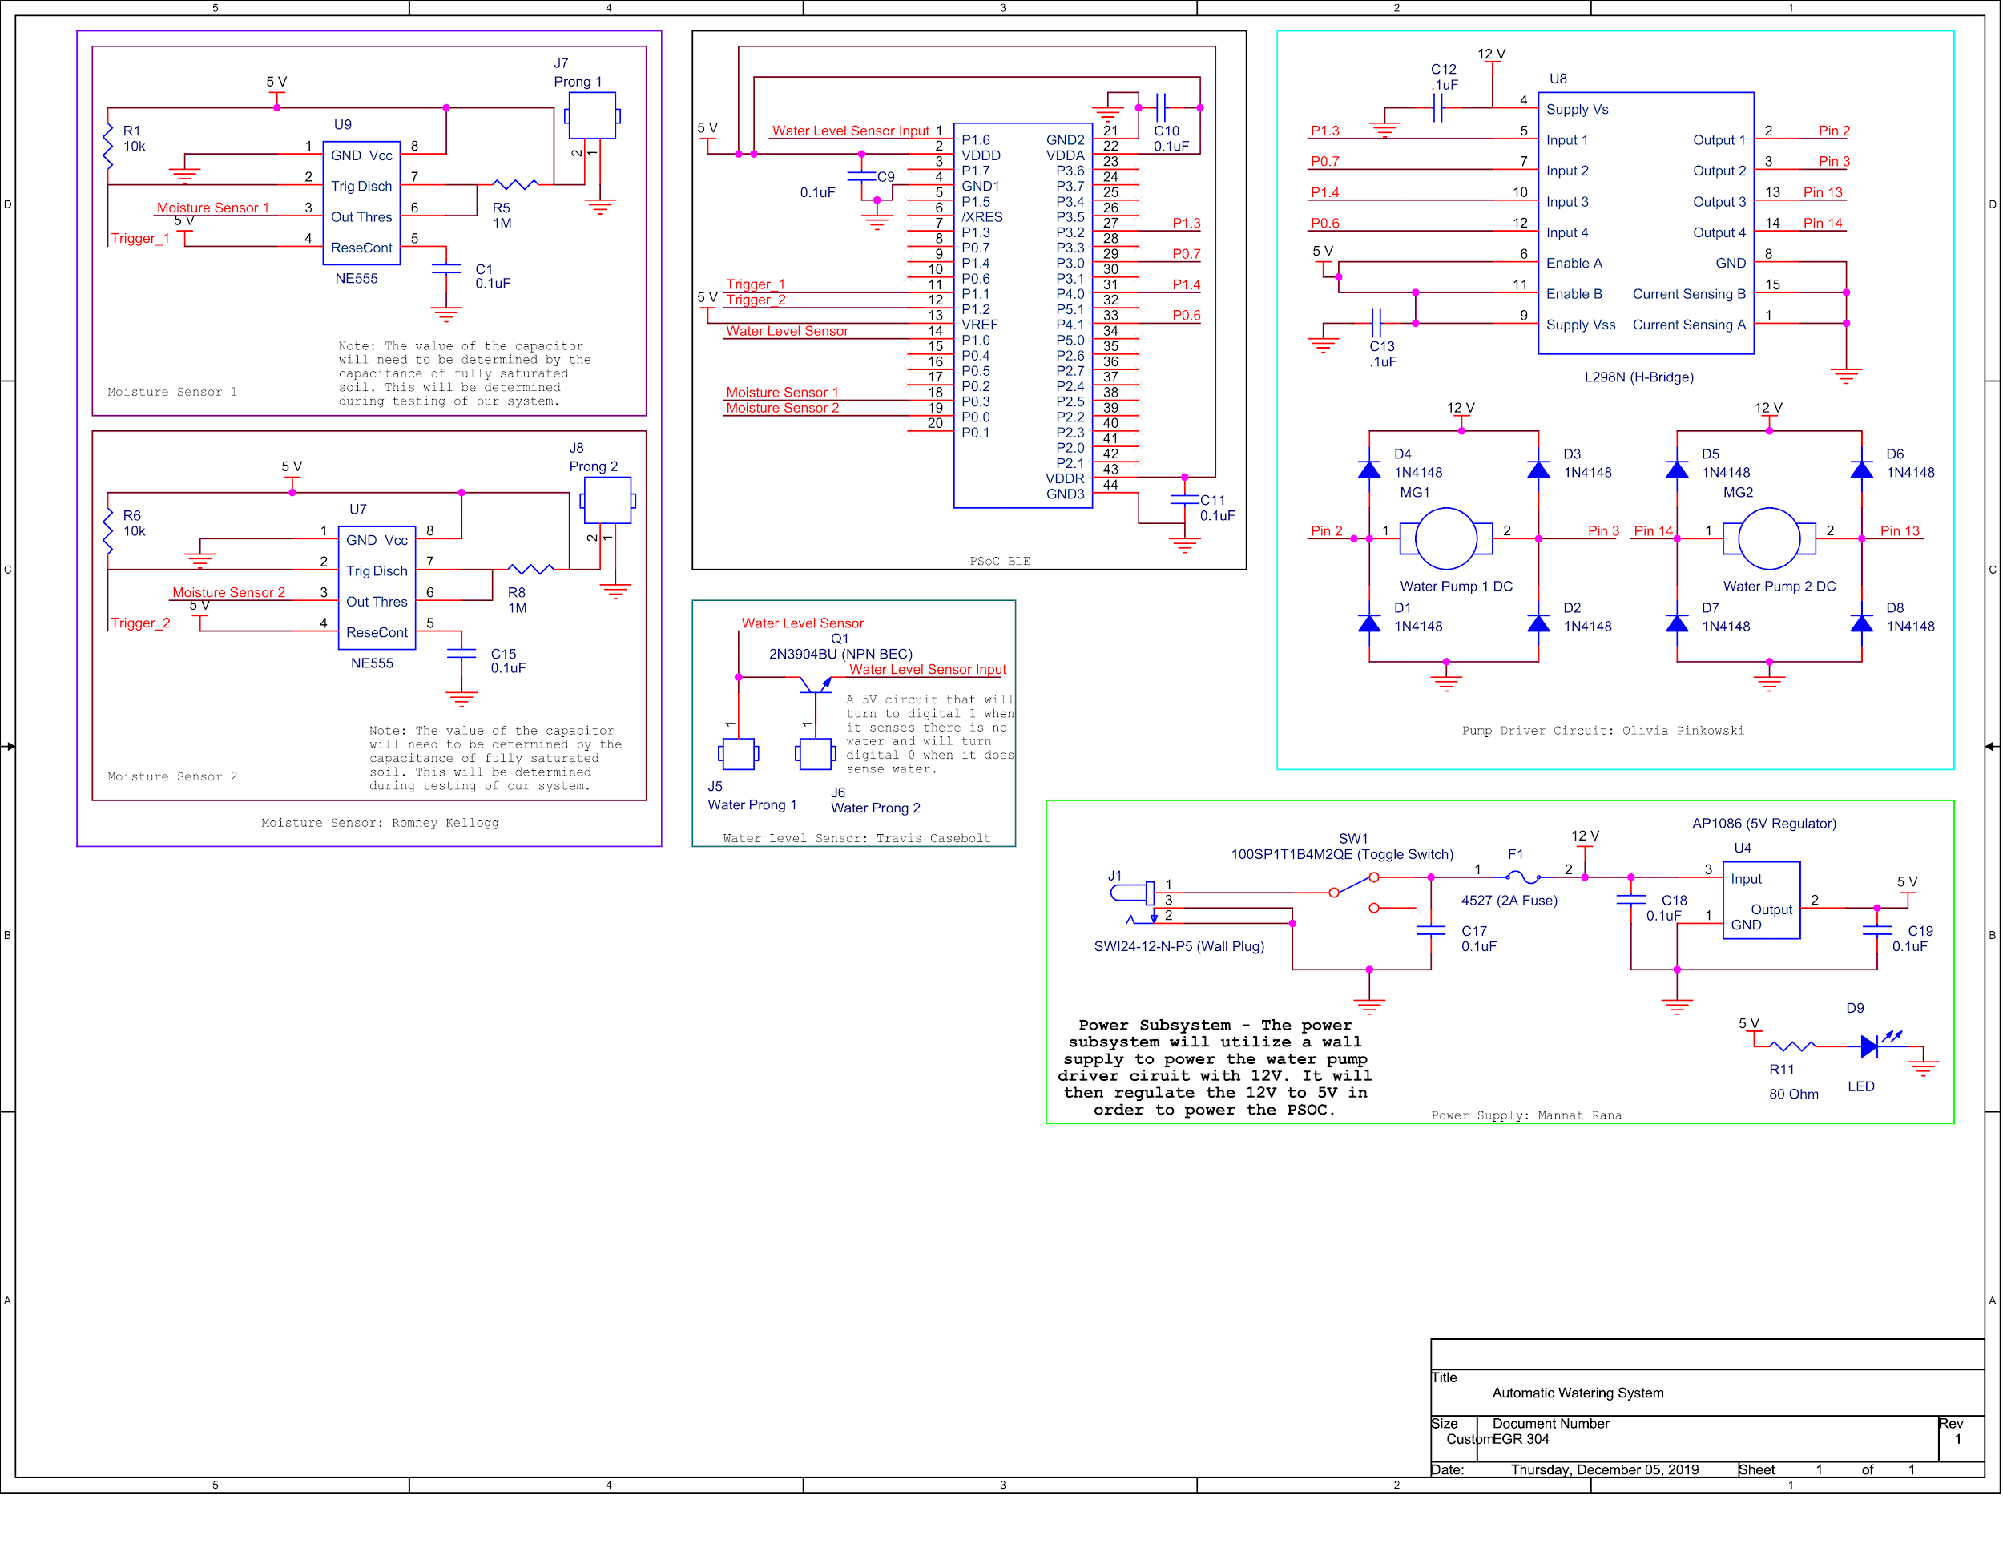

# Software Design Narrative:

In creating the software diagram, as a team, we relied heavily on our experience of creating software diagrams from previous classes. In times where our previous experience did not help us accomplish what we intended, we turned to the instructors and TA’s for guidance. Our team had a strong understanding of the direction we wanted to go with the coding which made creating the original software diagram very easy. The team utilized expertise from the TA’s Mykol and Sheena to gain this strong understanding. However, after the first Design Review, we realized our software diagram was overly complicated and issues with a timer to detect when to send notifications surfaced. Upon an in-depth reviewal of the diagram, the team found that we had indirectly created blocking loops due to the complexity and timer issues. To correct the diagram, the team took advice from the instructor, took out the timer and fixed the blocking loops.

## Software Design:

#### Figure 2: Software Diagram

## Software Design Rationale:

To simplify the software diagram, it’s a continuous loop that cycles through reading the water tank level, reading the moisture level and running the pump. Our team decided to have this be the main loop because we felt it was most efficient to accomplish our end goal of watering the user’s plants.

The software starts by checking the water level in the tank to ensure that there is enough water in the tank to water the plants. If there is not enough water in the tank then the software will change the HEX code in the CySmart app. This will continue until the software reads that the water tank is full, and then it will change the HEX code in the CySmart app. If the water tank is full then the software will move on to read the moisture sensor. In this section of the software, the software compares the value of the moisture to the threshold that is predetermined. If the threshold is exceeded, the pump will turn off. If the moisture level is below the threshold, then the pump will turn on, and the software will keep checking the moisture until the moisture is above the threshold, and will proceed to turn it off.

# Mechanical Design Narrative:

The mechanical design was engineered with three factors in mind: safety, durability, and flexibility for the user. These factors were chosen in order to make our design as safe as possible, as it would be operating at times with no human supervision. Because our device transfers water to plants automatically, the majority of our device needed to be waterproof. We did not want our device having any electrical issues as a result of a water leak. We also implemented a weight limit specification so that it could be easily and safely carried by an average adult user. To ensure the device is durable, we made it out of materials that would not easily break such as plastic and MDF. We also created a vinyl layer in order to further prevent any water damage to the base, which is made out of MDF. Using vinyl also allows the user to easily clean up any spills from the water tank. Finally, we implemented a feature to make our design as flexible for the user as possible. Both the water tank and planter boxes are removable, which allows the user to adjust them or use their own planter boxes if desired. This allows the user to have full control over where and how the device is set up.

## Mechanical Design Rationale:

The watering precision of the device was determined by two things: the pumps the team decided to purchase, and the amount of control the team could exercise over them from within the code. A simple H-Bridge driving circuit was designed to receive the controlling signals from the PSoC and then deliver the 12 Volt power required to operate the pumps. This circuit is easy to code, manipulate, and integrate with the PSoC Cypress software. Since the pumps operate in one direction, the team had two places to control each pump on the PSoC. This originated from both the positive and negative inputs on each side of the two H-Bridge systems within the package. This ensured if one connection pin failed during the manufacturing process, there was a spare. The pumps selected can move approximately 152.8 milliliters of water per second. Since we can control the amount of time the pumps run through the code, the desired amount of water can be released. Of the water pumps specced, this one moved the least amount of water making it the most accurate to dispense water based on time. This combination of pump and driving circuit allows our specification to be met.

To record if the water level was too low, the team connected a water level signal conditioning circuit to a notification system established through Bluetooth. The user can identify if the tank is too low by markers on the outside of the clear box or through the communication received through the Cypress application. The notification of a “0” is displayed while the circuit is incomplete and a “1” is displayed while it is complete. When the circuit sends a “0” it will tell the user that their tank is too low. If the PSoC gets a zero then that will stop the motors from being able to run since it will mean the water level is too low and could cause damage to the system. When the Cypress app and PSoC reads “1” it will allow the circuit to run normally.

The moisture level of the soil can be measured through the capacitive sensor. The sensor ranged from 11uF to 22pF. At full saturation, the sensor reads at 22pF and takes longer to discharge. This time difference allows us to read and interpret the varying levels in the moisture.

The base of the device is what currently defines the footprint. The planter boxes and the water tank must be enclosed within the base. The team decided to have all the components on the same level for ease of access. This resulted in a footprint of approximately $0.43 in^{2}$.

The initial input voltage is determined by the power source. The team utilized a standard American wall outlet to initially receive power from. A voltage converter with an American plug was selected to meet this specification.

To minimize the noise the device produces, the team decided on the submerged pumps. Since the pumps are the only source of noise from the system, we decided to have the water dampen the noise.

The independence of the device was defined by the number of times someone had to interact with the device. The team identified filling the tank as the maintenance operation for the device. This meant the user interaction would be determined by the tank size. As a result, the team decided to make the water tank more than twice the size of the planter boxes. Once the soil has initially been saturated then maintaining the saturation shouldn’t take much water, which greatly reduces the need for user interaction.

The entire system contributes to the total weight of the system. The base and water constitute the majority of the weight which weighs approximately 6.8 kilograms. The base was made of MDF board to better cut the pockets on the Shopbot CNC. Those pockets removed about a third the weight associated with the base. The water and soil weigh approximately 14.5 kilograms. When added to the device the total weight meets the set specification of 20.4 kilograms.

## Project in Context:



#### Figure 3: Device in Use

## Project Photos:

#### Figure 4: Assembled Planter Box Empty

#### 

#### Figure 5: Front View of Planter Box Empty

# Version 2.0+ and Lesson Learned

## Hardware Design:

Our hardware design could be greatly improved by keeping as many of our components and their traces on one side of the board. As of right now, many of our components have traces on both sides of the board. This design is risky for several reasons. Firstly, it heavily relies on pads to be continuous, which is not a fair assumption as with usage and heat, pads do break. Also, keeping more traces on one side of the board would reduce the number of vias needed, and vias are a significant problem in the vulnerability of the device. By making these improvements in a future version, we could avoid heavy amounts of electrical failure and debug.

Another improvement for a future version for our device would be to use more surface mount components. Using surface mount components, we could place components more densely which would allow for a smaller and more powerful board. Surface mount components also stand up to usage and vibrations much better, as many of our through-hole components have broken pads and came off. Overall, surface mount components would make our board smaller, easier to manufacture, and more durable.

## Software Design:

The software could be heavily improved by adding more customizability to the user. As of right now, the moisture level can only be controlled from modifying the code itself. In a future version, the team would implement a method for the user to adjust their desired moisture level through Bluetooth. This would make the device far more versatile, as well as put some more power into the hands of the user. Another feature that would make for a happier end consumer would be to send push notifications to the user. As of right now, the user has to enter the app to see if the water level is sufficient. In a future version, the device would send a push notification so that the user would know about the status of the water tank without having to manually check-in the application. This improvement would be beneficial as it would reduce the amount of work the user has to invest.

Another area the code could be improved in is in the precision of its measurements. As of right now, the device checks each sensor once before issuing a command. In a future version, it would be more helpful for the device to collect and analyze data for many samples, and using the final result of that data analysis to issue commands. This would make sure that outlier measurements do not have a major effect on the device’s performance. Therefore, the device would be more reliable for the end-user.

## Mechanical Design:

The mechanical design could be revised to stand on its own. Currently, the device sits on a tabletop, in the future, the design should include legs and the footprint can be minimized by making more like a tower rather than a tabletop. The water tank would be on the lowest level or tier. The tier above that could house one plant box, and the other box could go on the highest tier. This would make the device easier to work into a pre-existing environment and would ensure it can support itself.

The cutouts of the base can be made to perfectly form to the bottom of the boxes. This would ensure the box doesn’t move around. It would also make the final product more professional. The material of the base could change to a lighter material to make the device easier to move. The MDF was selected because of the manufacturing process but PlyWood would also work and it would be lighter. The plywood would also seal better. Since the device uses water and there is a potential of spilling, having the material be sealed would be a big benefit.

## Lessons Learned:

1. Simple hardware design for a sensor does not directly translate to it being easy to code.
2. Minimizing the amounts of loops in code, makes it very hard to debug device.
3. The less solder the better.
4. Keep as many of the components and traces on one side of the board. This makes the device far more reliable.
5. Check for shorts while soldering instead of soldering all components and then checking for shorts.
6. Digital sensors are much easier to code than analog sensors.
7. Through-hole components are not very durable compared to surface mounts.
8. Debugging requires more time than the initial construction itself.
9. Waterproof anything that may even be slightly in contact with water.
   1. Silicone or Epoxy works really well to seal devices versus using hot glue.
10. Reference datasheets first for any problems before trying to find solutions online.

# 

# Appendices:

## Benchmarking:

|  |  |  |  |
| --- | --- | --- | --- |
| **Solution** | **Description** | **Pros** | **Cons** |
| Orb Watering Can - Company has stopped selling this product on their own site but it is still sold on Amazon    [https://blazinbison.com](https://blazinbison.com/)  $15.00 | The Orb watering can passively water your plants until the water runs out. The user fills the glass tube and sticks it into the dirt with the plants | * Easy to install * Compatible with all gardens * Self-Water * Passive (no power required) * Inexpensive * Decorative | * There is a finite amount of water and requires maintenance * Fragile * Only supplies water to the plant with roots directly under it (only waters one plant) |
| Home Watering System    [Home Watering System](https://www.amazon.com/Upgraded-Automatic-Watering-Irrigation-Programmable/dp/B07P9ZH7PQ/ref=sr_1_1?keywords=home+watering+systems&qid=1567546038&s=gateway&sr=8-1)  $36.99 | Automatic Watering System, Automatic Drip Irrigation Kit with 30-Day Digital Programmable Water Timer for 8 Indoor Potted Plants Vacation Plant Watering System | * Automatic * Utilizes little space * Easy installation * Simple Interface * Regulates the water usage * Has the ability to water multiple plants at a time | * Time-based system * Unattractive * Price is high for what it does * Does not dispense water based on plant’s needs |
| Automatic Drip Water System    <https://claber.us/>  $105.99 | Claber 8053 Oasis 4-Programs/20 Plants Garden Automatic Drip Watering System | * Can water multiple plants at a time * Little Maintenance * 4 pre/programmed settings * Passive System | * Runs on a 9V battery * Bulky * 6.6-gallon tank (must refill) * Difficult to understand when the device is operating |
| Indoor Water irrigation system    [Wisfor Watering System](https://www.amazon.com/Wisfor-Watering-System-Irrigation-Automatic/dp/B07RXWJ9NJ/ref=sxbs_sxwds-stvp?keywords=home+watering+systems&pd_rd_i=B07RXWJ9NJ&pd_rd_r=4f54dc4b-c609-4e8e-a7ba-e2c1870863b5&pd_rd_w=uiagY&pd_rd_wg=M28S1&pf_rd_p=a6d018ad-f20b-46c9-8920-433972c7d9b7&pf_rd_r=Z94MZ56PNVMJWD9QS26J&qid=1567546331&s=gateway)  $37.99 | Wisfor Watering System Indoor Irrigation Plant Self Water Drip System for Potted Plants Automatic Drip Watering System with 10M Tube | * Waters multiple plants at a time * Simple interface | * Runs on 4 AAA batteries * No means to hold water has to run a hose to a separate water reservoir |
| Watering Can    <https://bloemliving.com/>  $6.99 | Bloem Aqua Rite Watering Can, 56 oz, Calypso (AW21-27) | * Simple to use * Inexpensive and Affordable * User Controls how much water the plant receives | * Requires lots of “maintenance” * Not automatic in dispensing water |

**Differentiating Characteristics:**

When compared to the other items listed, our project will be more suited for the urban lifestyle due to its ability to measure moisture in the soil, water plants a certain amount based on the moisture reading and send reminders to the user when the water tank needs to be refilled. Our project will be the most self-sufficient option on the market because of these three things. It is also the easiest for the user to use because they only need to turn on the device, fill the water tank and put what plants they want to grow in the planter boxes. This way the user doesn’t need to be bothered with learning how to use the hardware. Once it is set up, they can forget it until the water tank needs to be refilled, or they switch the plants needed to be watered.

## 

## Bill of Materials:

|  |  |  |  |  |  |  |  |  |  |  |  |  |  |  |
| --- | --- | --- | --- | --- | --- | --- | --- | --- | --- | --- | --- | --- | --- | --- |
| **Bill of Materials** | | | | | | | | | | | | | | |
| **Part Name/ Description** | **Unit Quantity** | **Unit Prototype Cost** | **Total Prototype Cost** | **Unit Production Cost** | **Total Production Cost** | **Manufacturer** | **Manufacturer Part #** | **Supplier** | **Supplier Part #** | **# Ordered** | **Date Ordered** | **# Received** | **Surplus** | **Schematic Reference Designators** |
| Water Pumps | 3 | $9.48 | $28.44 | $9.48 | $28.44 | DFRobot | FIT0563 | DigiKey | 1738-1398-ND | 3 | 9/29/2019 | 3 | 0 | MG1, MG2 |
| H-Bridge | 3 | $4.86 | $14.58 | $2.57 | $7.70 | STMicroelectronics | L298N | DigiKey | 497-1395-5-ND | 3 | 9/29/2019 | 3 | 0 | U8 |
| Female Barrel Connector | 2 | $0.82 | $1.64 | $0.41 | $0.82 | CUI Devices | PJ-009AH | DigiKey | CP-009AH-ND | 2 | 9/29/2019 | 2 | 0 | J1 |
| Wall Plug | 1 | $17.45 | $17.45 | $12.54 | $12.54 | CUI Inc. | SWI24-12-N-P5 | DigiKey | 102-3623-ND | 1 | 9/29/2019 | 1 | 0 | N/A |
| Fuse Holder | 2 | $0.62 | $1.24 | $0.28 | $0.56 | Keystone Electronics | 4527 | DigiKey | 36-4527-ND | 2 | 9/29/2019 | 2 | 0 | N/A |
| Voltage Regulator | 2 | $0.89 | $1.78 | $0.64 | $1.27 | Diodes Incorporated | AP1086T50L-U | DigiKey | AP1086T50L-UDI-ND | 2 | 9/29/2019 | 2 | 0 | U4 |
| Fuse | 4 | $1.52 | $6.08 | $0.62 | $2.48 | Littelfuse Inc. | 0477002.MXP | DigiKey | F2987-ND | 4 | 9/29/2019 | 4 | 0 | F1 |
| Switch | 2 | $2.43 | $4.86 | $1.37 | $2.74 | E-Switch | 100SP1T1B4M2QE | DigiKey | EG2355-ND | 2 | 9/29/2019 | 2 | 0 | S1 |
| Header Pins | 2 | $0.88 | $1.76 | $0.44 | $0.88 | Sullins Connector Solutions | PPPC131LFBN-RC | DigiKey | S7046-ND | 2 | 9/29/2019 | 2 | 0 | J6 |
| Header Pins | 5 | $1.44 | $7.20 | $0.69 | $3.46 | Harwin Inc. | M22-2581005 | DigiKey | 952-2146-ND | 5 | 9/29/2019 | 5 | 0 | N/A |
| Header Pins | 4 | $0.57 | $2.28 | $0.35 | $1.41 | Molex | 22284150 | DigiKey | WM50014-15-ND | 4 | 9/29/2019 | 4 | 0 | N/A |
| NPN Transistor | 2 | $0.21 | $0.42 | 0.04043 | $0.08 | ON Semiconductor | 2N3904BU | DigiKey | 2N3904FS-ND | 2 | 9/29/2019 | 2 | 0 | Q1 |
| Diode | 20 | $0.06 | $1.20 | 0.0138 | $0.28 | ON Semiconductor | 1N4148 | DigiKey | 1N4148FS-ND | 20 | 9/29/2019 | 20 | 0 | D1, D2, D3, D4, D5, D6, D7, D8 |
| Op Amp | 4 | $0.87 | $3.48 | 0.3132 | $1.25 | Texas Instruments | LM741CN/NOPB | DigiKey | LM741CNNS/NOPB-ND | 4 | 9/29/2019 | 4 | 4 | N/A |
| Bypass capacitor (10 pack) | 1 | $0.17 | $0.17 | 0.03639 | $0.04 | Kemet | C1206C104K4RACAUTO | DigiKey | 399-C1206C104K4RACAUTOCT-ND | 1 | 9/29/2019 | 1 | 0 | C2, C9, C10, C11, C12, C13, C16, C17 |
| 150 Ohm Resistor | 4 | $0.10 | $0.40 | 0.00729 | $0.03 | Stackpole Electronics Inc | CF14JT150R | DigiKey | CF14JT150RCT-ND |  | 9/29/2019 |  | -4 | ** |
| NE555 | 4 | $0.45 | $1.80 | 0.1209 | $0.48 | Texas-Instruments | NE555P | DigiKey | 296-1411-5-ND | 12 | 9/29/2019 | 12 | 8 | U7, U9, |
| 10k ohm resistor | 8 | $0.40 | $3.20 | 0.00326 | $0.03 | Stackpole Electronics Inc | CF14JT10K0 | DigiKey | CF14JT10K0 |  | 10/30/19 | 8 | -8 | R1, R5, R6, R8 |
| 103LF Potentiometer | 3 | 1.93 | $5.79 | 1.197 | $3.59 | Bourns | 3296W-1-103LF | Allied | 70154543 | 3 | 10/30/19 | 3 | 0 | R9, R10, |
| 3/4 MDF | 6 | 1.08 | $6.48 | 1.08 | $6.48 | N/A | N/A | Innovation Hub | N/A | 6 | 11/19/19 | 6 | 0 | N/A |
| 1/4 Acrylic | 6 | 7 | $42.00 | 7 | $42.00 | N/A | N/A | Innovation Hub | N/A | 6 | 11/20/19 | 6 | 0 | N/A |
| Green Vinyl | 6 | 0.55 | $3.30 | 0.55 | $3.30 | N/A | N/A | Innovation Hub | N/A | 6 | 11/20/19 | 6 | 0 | N/A |

## 

## 

## Printed Circuit Board Layout:

#### Figure 6: Final PCB Design from PCB Editor

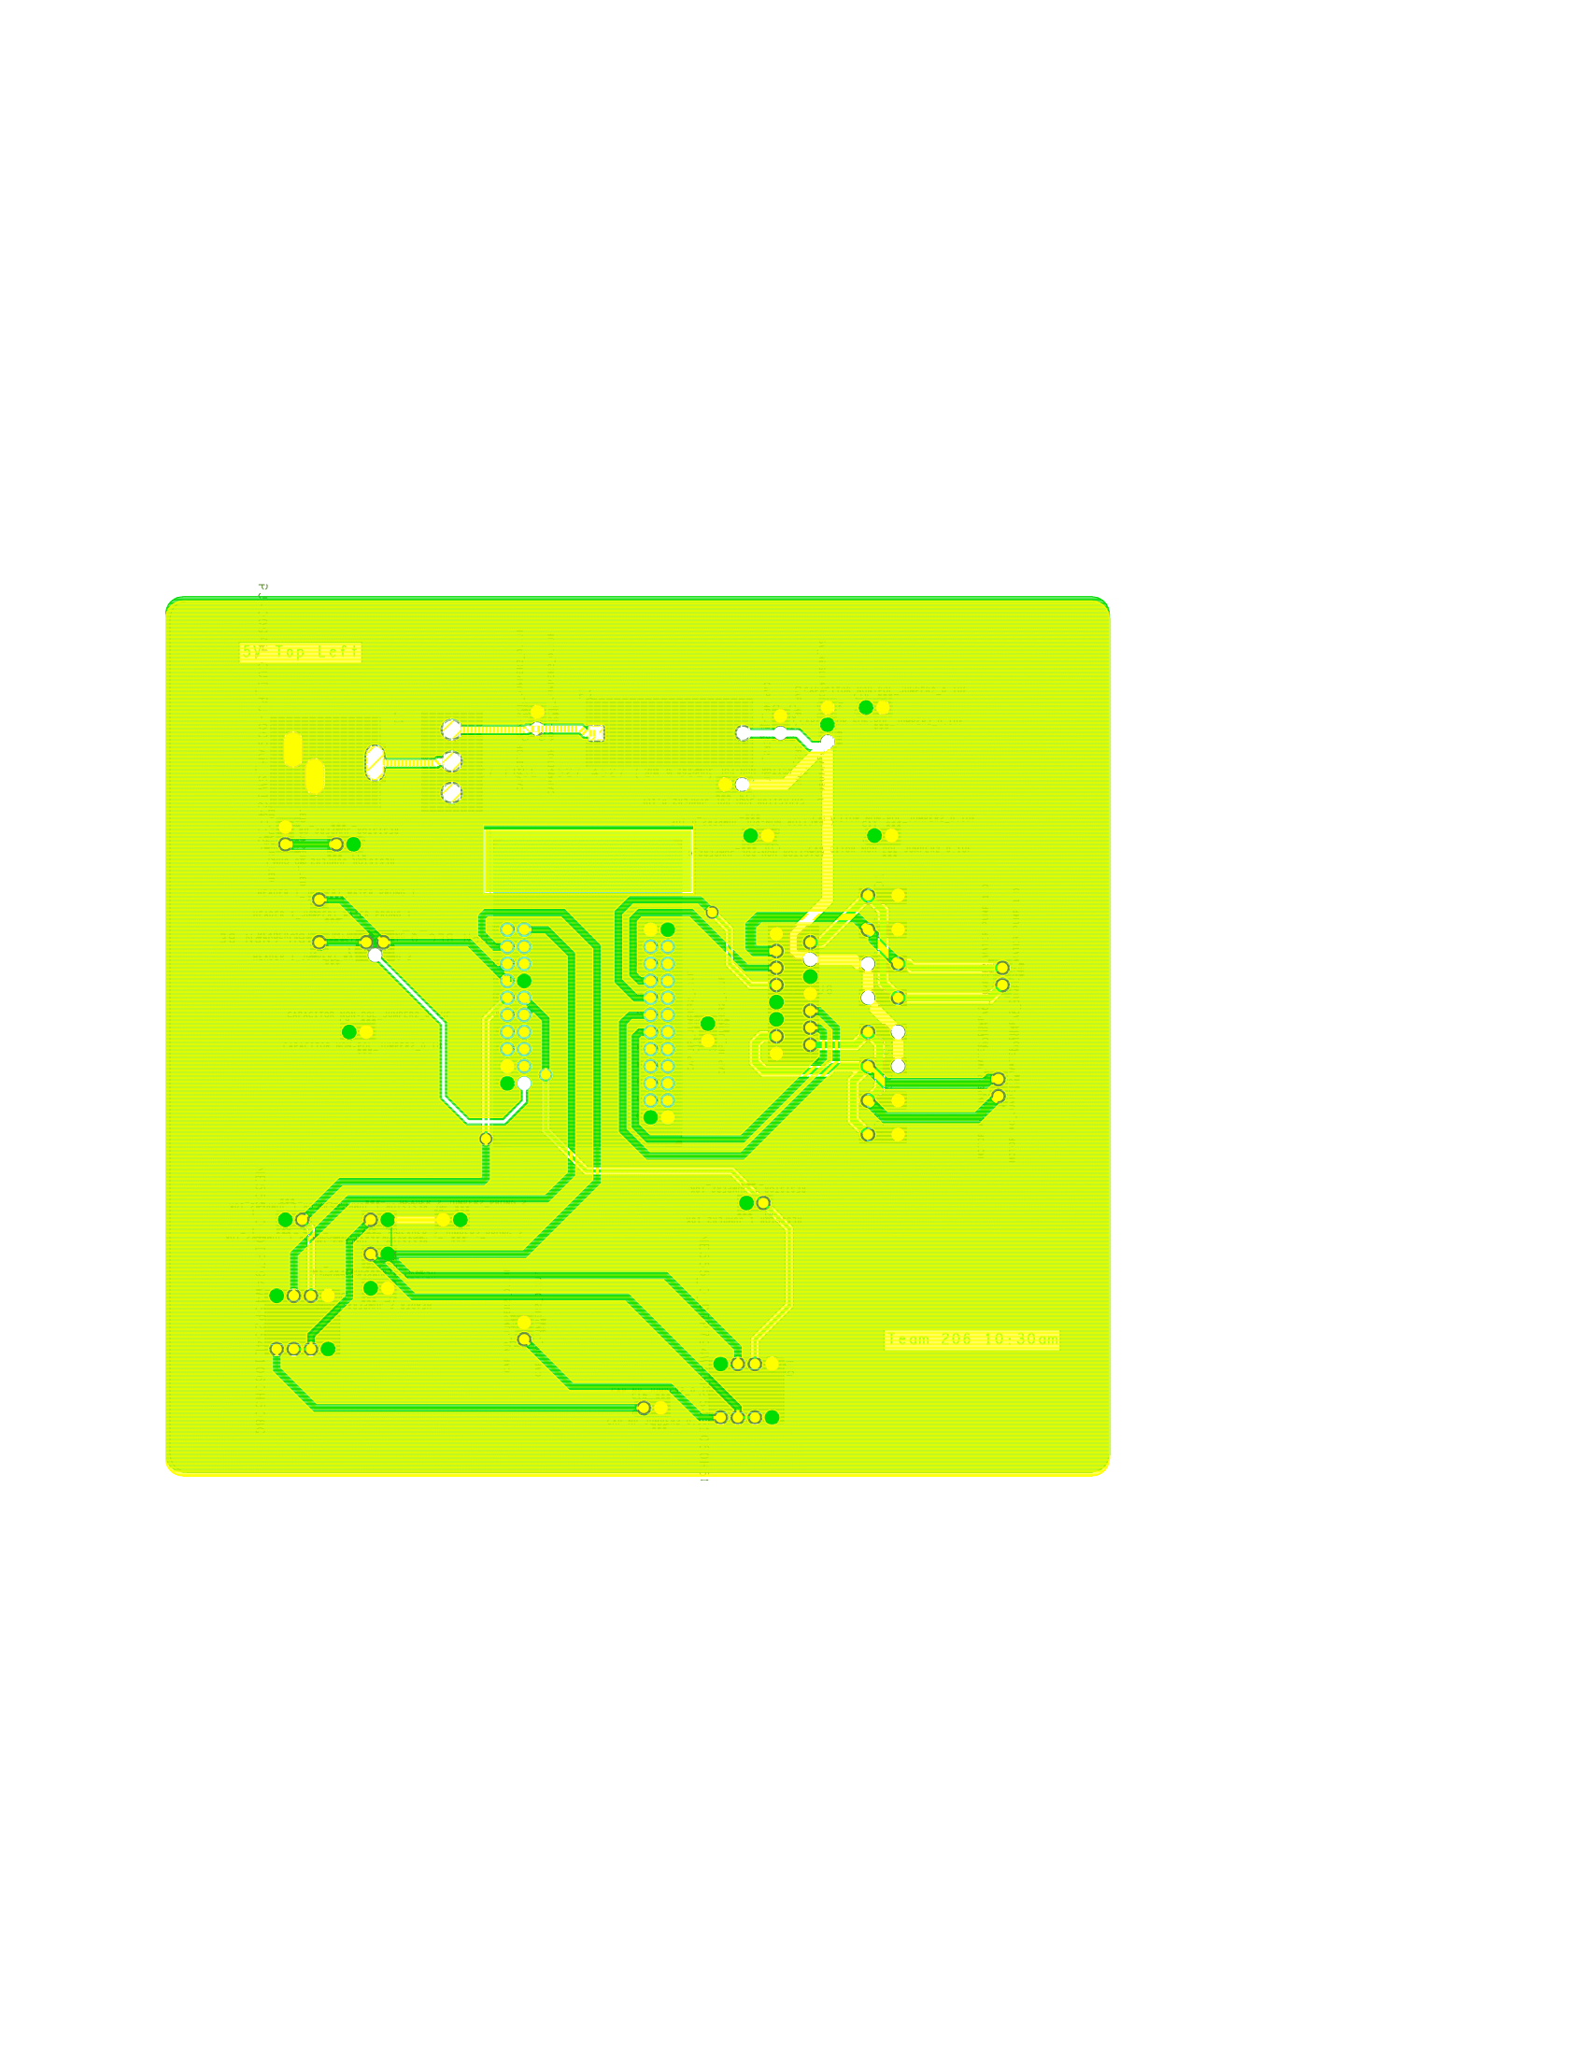

#### Figure 7: PCB Editor PDF Print Out

#### 

#### Figure 8: Printed PCB

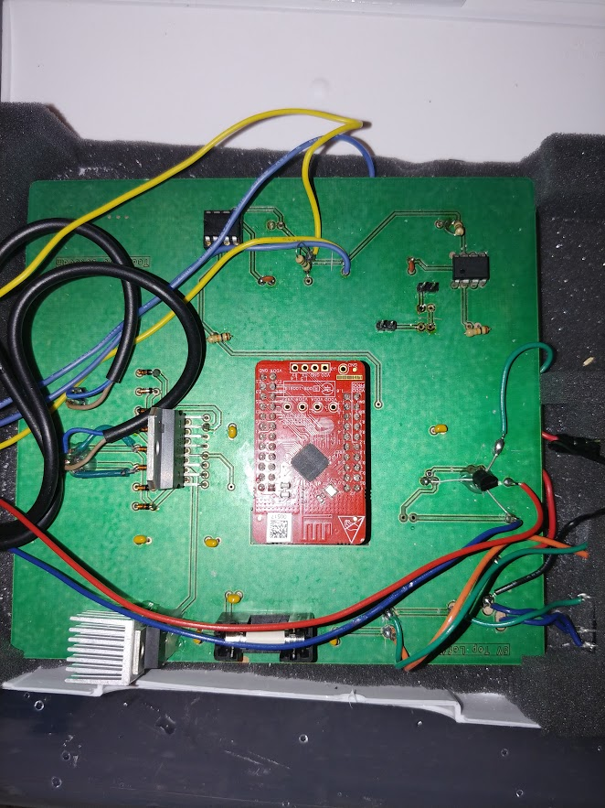

#### Figure 9: Soldered PCB

## 

## Code:

/*******************************************************************************

* Included headers

*******************************************************************************/

#include <project.h>

#include <stdio.h>

/*******************************************************************************

* Macros

*******************************************************************************/

#define FALSE 0u

#define TRUE 1u

#define LED_OFF 1u

#define LED_ON 0u

#define Ch1Period (9000)

#define SAMPLESIZE (4)

#define WDT_COUNTER (CY_SYS_WDT_COUNTER1)

#define WDT_COUNTER_MASK (CY_SYS_WDT_COUNTER1_MASK)

#define WDT_INTERRUPT_SOURCE (CY_SYS_WDT_COUNTER1_INT)

#define WDT_COUNTER_ENABLE (1u)

#define WDT_1SEC (32767u)

/*Global Variables*/

uint8 authReq;

uint8 notificationsEnabled=FALSE;

uint16 temperature;

volatile uint32 WDTInterrupt;

uint8 temp[2];

uint8 camp[2];

static int intFlag = 0;

int MoistureLevel;

static volatile uint32 Channel_1_Count;

/******************************************************

* Function Declaration: Initializing Bluetooth

*******************************************************/

void StackEventhandler(uint32 event,void * eventParam);

void StackEventhandler(uint32 event,void * eventParam)

{

CYBLE_GATTS_WRITE_REQ_PARAM_T *wrReqParam;

switch(event)

{

case CYBLE_EVT_STACK_ON:

/*Start Advertising*/

CyBle_GappStartAdvertisement(CYBLE_ADVERTISING_FAST);

break;

case CYBLE_EVT_GAPP_ADVERTISEMENT_START_STOP:

if(CyBle_GetState()==CYBLE_STATE_DISCONNECTED)

{/*Start advertising if time out happens*/

CyBle_GappStartAdvertisement(CYBLE_ADVERTISING_FAST);

}

if(CyBle_GetState()==CYBLE_STATE_ADVERTISING)

{

Advertising_LED_Write(LED_ON);

}

break;

case CYBLE_EVT_GAP_DEVICE_CONNECTED:

break;

case CYBLE_EVT_GAP_DEVICE_DISCONNECTED:

notificationsEnabled=FALSE;

/*Start advertising again*/

CyBle_GappStartAdvertisement(CYBLE_ADVERTISING_FAST);

break;

case CYBLE_EVT_GATTS_WRITE_REQ:

wrReqParam=(CYBLE_GATTS_WRITE_REQ_PARAM_T*) eventParam;

/*If notification is enabled*/

if(wrReqParam->handleValPair.attrHandle==

CYBLE_CUSTOM_SERVICE_CUSTOM_CHARACTERISTIC_CLIENT_CHARACTERISTIC_CONFIGURATION_DESC_HANDLE)

{

if(*wrReqParam->handleValPair.value.val==0x01)

{

notificationsEnabled=TRUE;

}

else if(*wrReqParam->handleValPair.value.val==0x00)

{

notificationsEnabled=FALSE;

}

}

CyBle_GattsWriteRsp(cyBle_connHandle);

break;

default:

break;

}

}

//interupt procedure

CY_ISR(isr_1_Handler) {

intFlag = Timer1_ReadStatusRegister(); // Read and clear interrupt status

if(intFlag & Timer1_STATUS_CAPTURE) { //if there is an interrupt caused by a capture

Channel_1_Count = Ch1Period - Timer1_ReadCapture(); //record the time

}

Timer1_Stop(); // stop and setup for next round

Timer1_WriteCounter(Ch1Period); // Rewrite counter for next cycle

}

/*******************************************************************************

* Function Name: main

********************************************************************************

*

* Summary:

* Main function.

*

* Parameters:

* None

*

* Return:

* None

*

* Theory:

* This function initializes the BLE component and then procesthe BLE events routinely

*******************************************************************************/

int main()

{

CYBLE_GATTS_HANDLE_VALUE_NTF_T serverTemp; //Start server

CyGlobalIntEnable; //Enable global interrupts

isr_1_StartEx(isr_1_Handler); //Initialize interrupt

Timer1_Start(); //Start timer

CyBle_Start(StackEventhandler); //Start BLE

for(;;) //Main loop

{

CyBle_ProcessEvents(); //Process Bluetooth Events

if(CyBle_GetState()==CYBLE_STATE_CONNECTED && notificationsEnabled==TRUE) //If user has connected their phone and notifications are enabled

{ //create hex codes to be printed

temp[1]= 1;

temp[0]= 0;

camp[1]= 0;

temp[0]= 0;

//Make decisions based on water level

switch (WaterLevel_Read()) {

case 1: //if water level is high

serverTemp.attrHandle=CYBLE_CUSTOM_SERVICE_CUSTOM_CHARACTERISTIC_CHAR_HANDLE;

serverTemp.value.val=temp;

serverTemp.value.len=sizeof(temp); //print 0001 in hex value

//trigger the 555 timer

Trigger1_Write(0);

Trigger1_Write(1);

CyDelay(1);

if (intFlag) {

Timer1_Start();

}

if (Channel_1_Count < 1750) { //if the moisture sensor reads dry

MoistureLevel = 1; //set moisture level to one

}

else { //if moisture level reads dry

MoistureLevel = 0; //set moisture level to zero

}

break;

case 0: //if water level is low

serverTemp.attrHandle=CYBLE_CUSTOM_SERVICE_CUSTOM_CHARACTERISTIC_CHAR_HANDLE;

serverTemp.value.val=camp;

serverTemp.value.len=sizeof(camp); //print 0000 in hex value

Pump2_Write(0); //turn pumps off

break;

}

if(CYBLE_ERROR_OK==CyBle_GattsNotification(cyBle_connHandle,&serverTemp))

{

WDTInterrupt=FALSE;

}

}

if (MoistureLevel == 1) {

Pump2_Write(1); //turn on pump

}

else {

Pump2_Write(0); //turn off pump

}

}

}

## 

## User Manual:

Steps to use the Automatic Watering System:

1. Ensure that the water tank is filled up. The water tank can be easily removed from the device if needed. Fill the water tank up until the fill line marked at 50% full on the water tank.

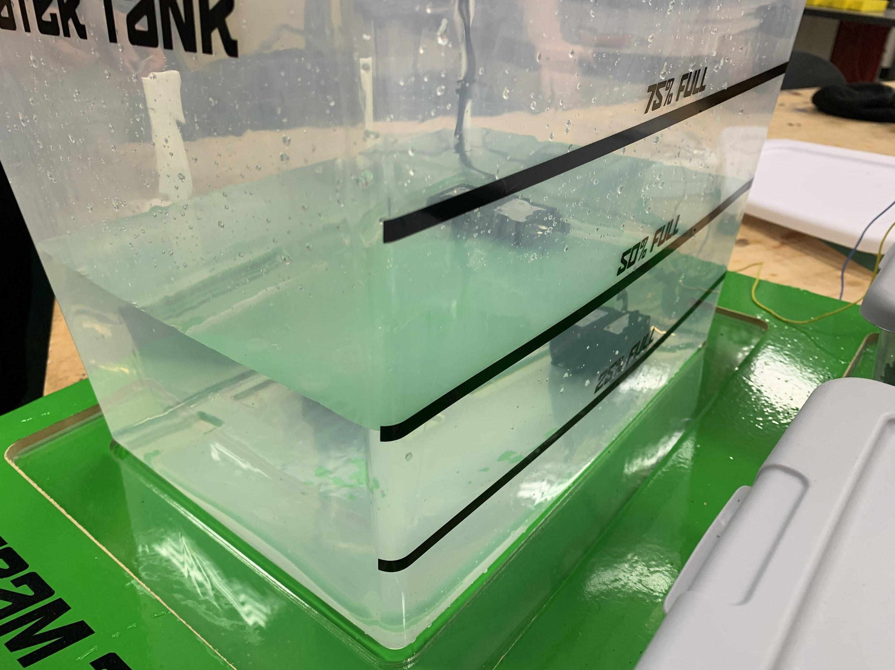

#### Figure 10: Image of the water tank filled to an appropriate level.

1. Fill planter boxes with the desired soil and plant. These boxes can also be easily removed if needed. Fill the planter boxes with the soil until the fill line marked on all four top corners of the boxes, or to the user’s desired amount.

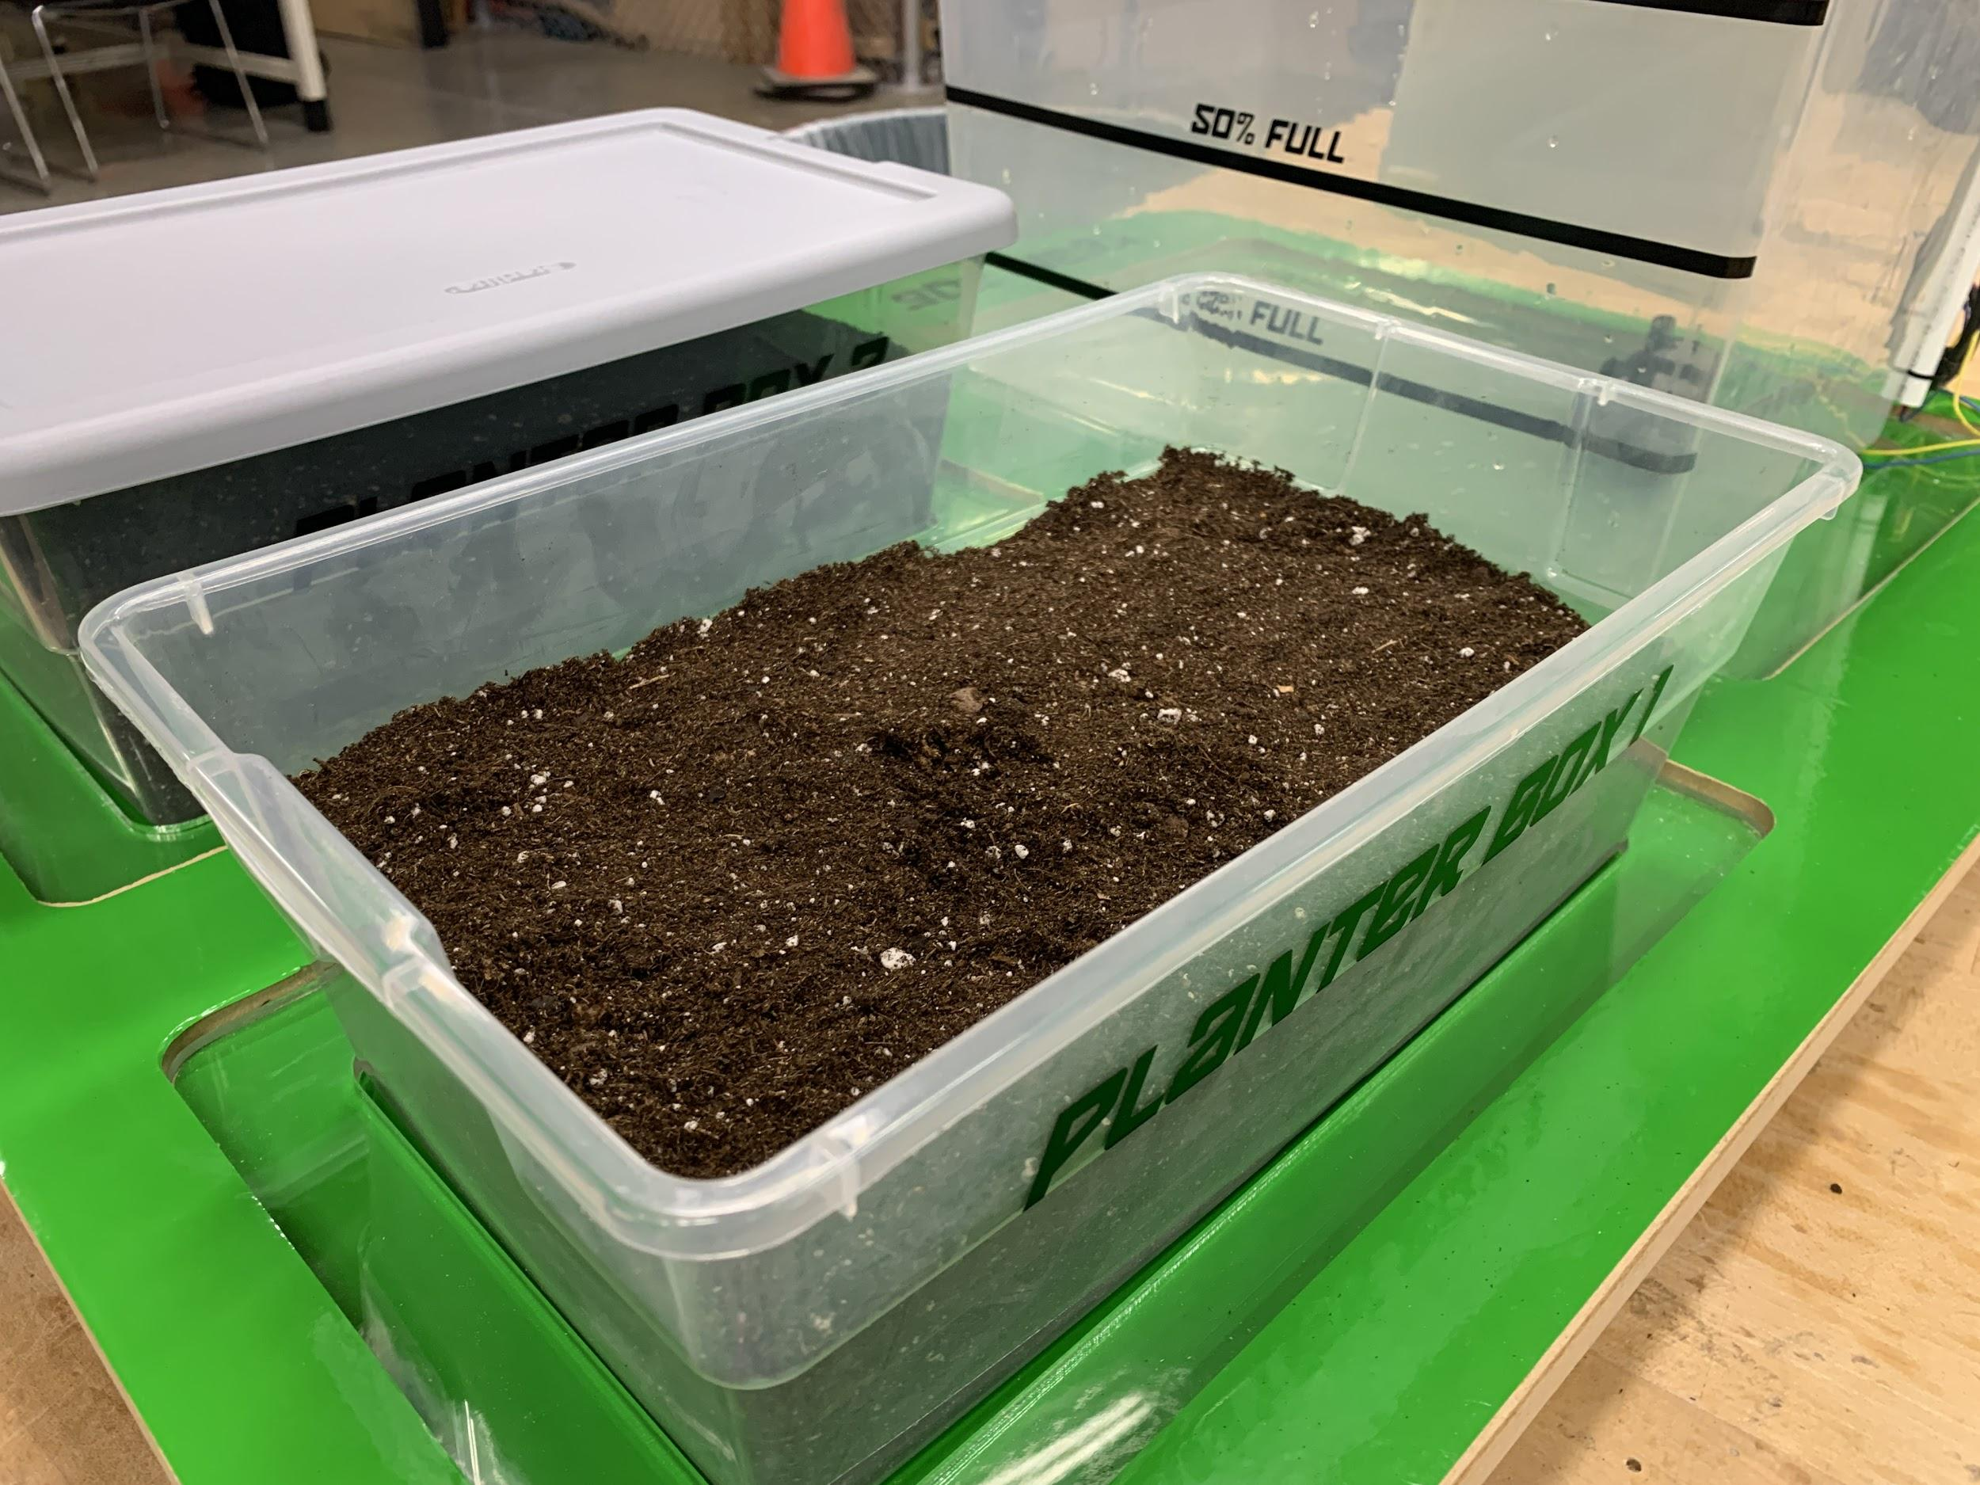

#### Figure 11: Image of the planter box filled with soil to an appropriate level.

1. Place one moisture sensor into the soil of plant box one with the pointed side going in first. The moisture sensor should be submerged until the marked line on the top of the sensor in the soil. Do not fully submerge the sensor.

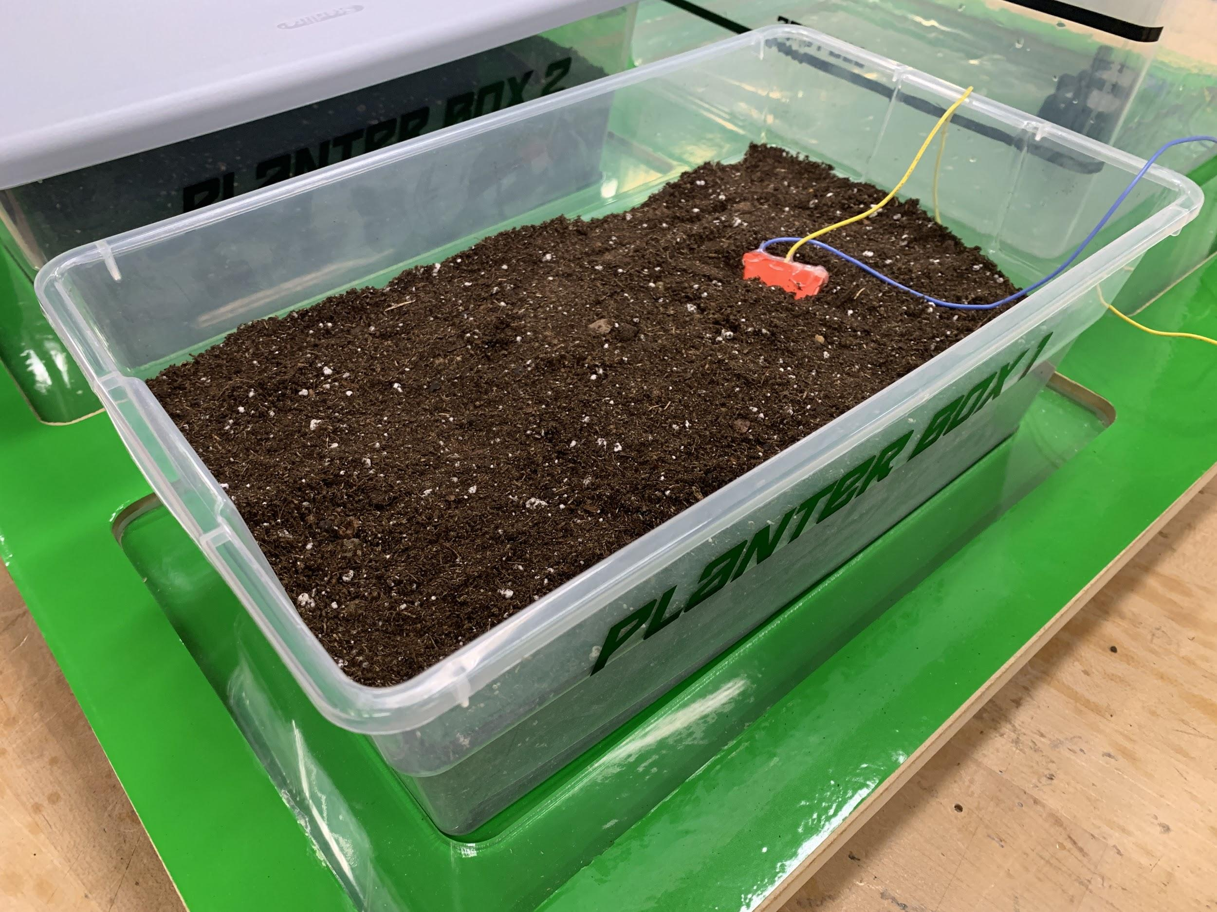

#### Figure 12: An image of the moisture sensor placed correctly in the soil.

1. Repeat step 3 for the second planter box using the second moisture sensor.
2. Plug the device into the wall. The device comes with a US outlet standard plug. Figure 13 shows the power supply correctly plugged into the device and an outlet.

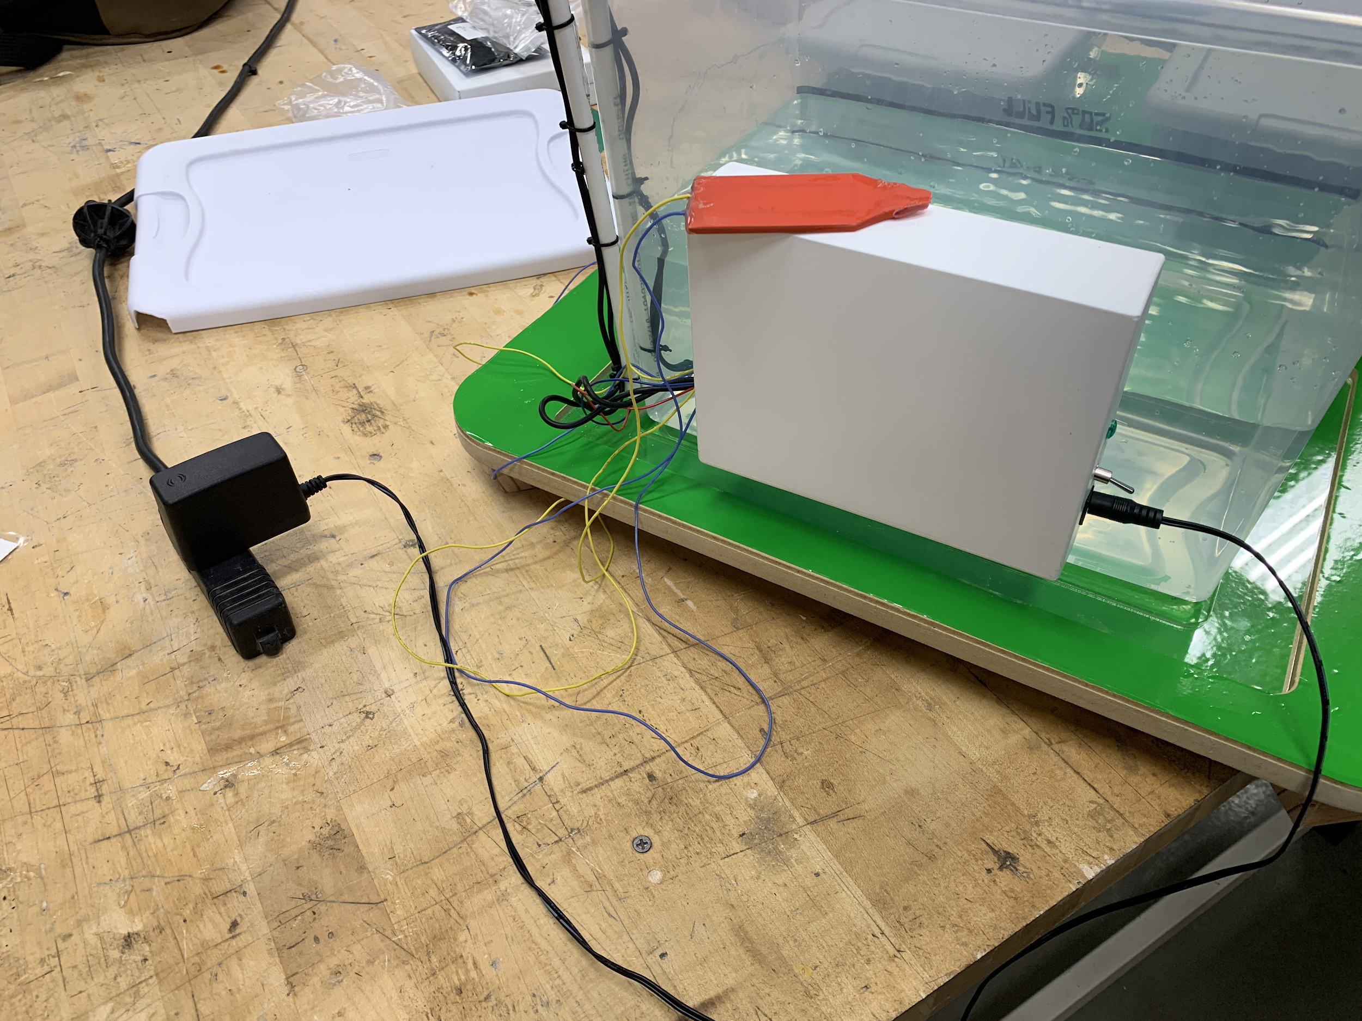

#### Figure 13: Power Supply

1. Flip the switch upward. This will power the device and allow the device to function.

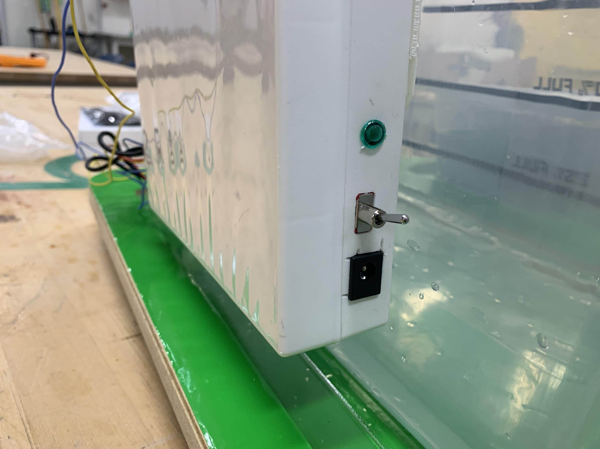

#### Figure 14: Image of the power switch while the device is on.

1. Access the device under the CySmart application. Select Autonomous Watering System in setting, and follow through the folder labeled GATT DB. Once in, hit start notify and you will be able to interpret the HEX value as the sufficiency of the water level of the tank. If the HEX Value shows 0001, then the tank has a sufficient amount of water. If the HEX Value shows 0000, then the tank needs to be refilled. The left image in Figure 15 shows the HEX code when the water level is insufficient, and the right image in Figure 15 shows the HEX code when the level is sufficient.



#### Figure 15: Screenshots of the Bluetooth screen.

### Troubleshooting

Problem: The device is not dispersing water, even in completely dry soil.

Solution: The moisture sensor is most likely shorted. The best way to fix this is to leave the sensor out of the soil for several days. This will allow the water to dry up, and sensor to no longer be shorted.

Problem: The water tank always reads 0000 in the CySmart app, even when the tank is filled.

Solution: The water level sensor has most likely disconnected. Remove the water, and then bring the wires along the height of the tank closer to each other. Once the tank is refilled, the sensor should once again be functional.

Problem: Nothing on the device seems to be working, even after applying the above two solutions.

Solution: The device has most likely blown its fuse. Open up the electronics box attached to the side of the water tank, and replace the fuse.

## 

## CAD Model:

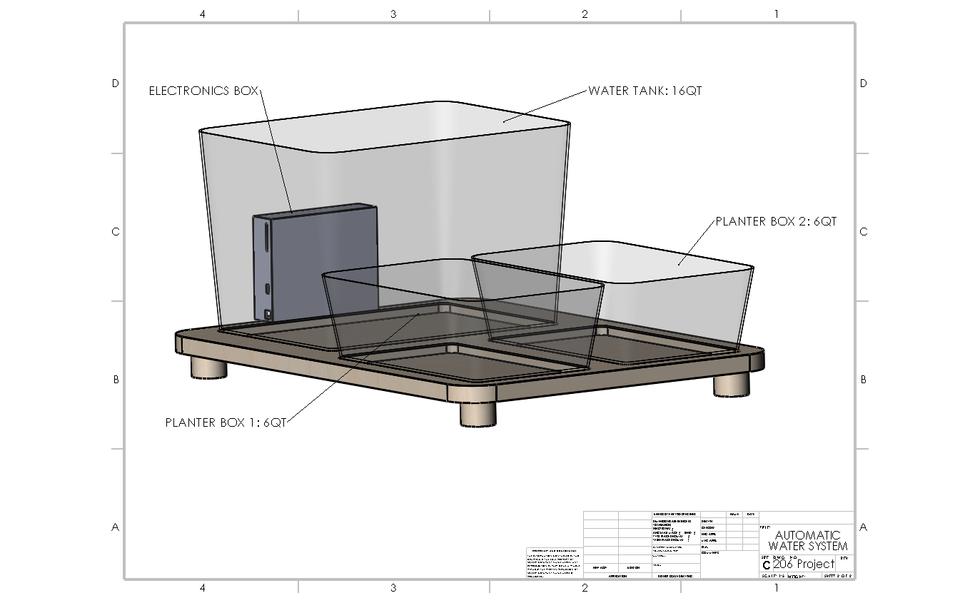

#### Figure 16: Empty Device

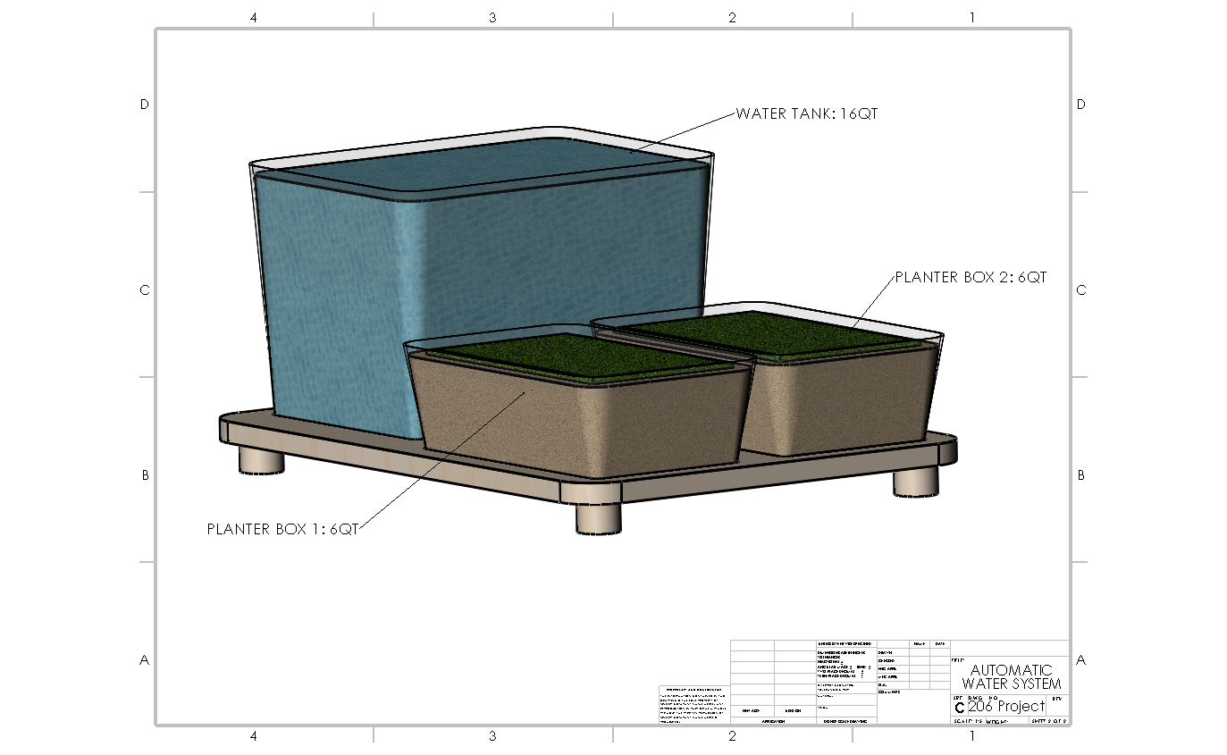

#### Figure 17: Device With Organic Material

## References:

[1] Cypress. (2017, July 10th). *PSoC® 4: PSoC 4200 Family Datasheet*.

Retrieved from:<https://www.cypress.com/file/138656/download>

[2] Texas Instruments. (2014, September). *xx555 Precision Timers.*

Retrieved from:<http://www.ti.com/lit/ds/symlink/ne555.pdf>

[3] STMicroelectronics. (2000, January). *DUAL FULL-BRIDGE DRIVER L298*.

Retrieved from:<https://www.sparkfun.com/datasheets/Robotics/L298_H_Bridge.pdf>

[4] CUI Devices. (2018, August 31st). *SERIES: SWI24-N.*

Retrieved from:<https://www.cui.com/product/resource/swi24-n.pdf>

[5] Texas Instruments. (2015, October). *LM741 Operational Amplifier.*

Retrieved from:<http://www.ti.com/lit/ds/symlink/lm741.pdf>

[6] Texas Instruments. (2015, January). *LM555 Timer.*

Retrieved from:<http://www.ti.com/lit/ds/symlink/lm555.pdf>

[7] DFRobot. (2018, May). *DC Mini Immersible Water Pump (6V~12V).*

Retrieved from: <https://media.digikey.com/pdf/Data%20Sheets/DFRobot%20PDFs/FIT0563_Web.pdf>

[8] Diodes INC. (2010, June). *AP1086 1.5A LOW DROPOUT POSITIVE ADJUSTABLE OR FIXED-MODE REGULATOR*.

Retrieved from:<https://www.diodes.com/assets/Datasheets/AP1086.pdf>

[9] ON Semiconductors. (2012, August) *General Purpose Transistors*.

Retrieved from:<https://www.onsemi.com/pub/Collateral/2N3903-D.PDF>

[10] CUI Devices. (2019, October). *MODEL: PJ-009AH DESCRIPTION: DC POWER JACK.*

Retrieved from:<https://www.cuidevices.com/product/resource/pj-009ah.pdf>